[Procedure Title]
Other than the headings and the Meta Data Document Management table in section 8, all other text is for guidance only and should be removed from the final procedure.
- Headings and styles for use
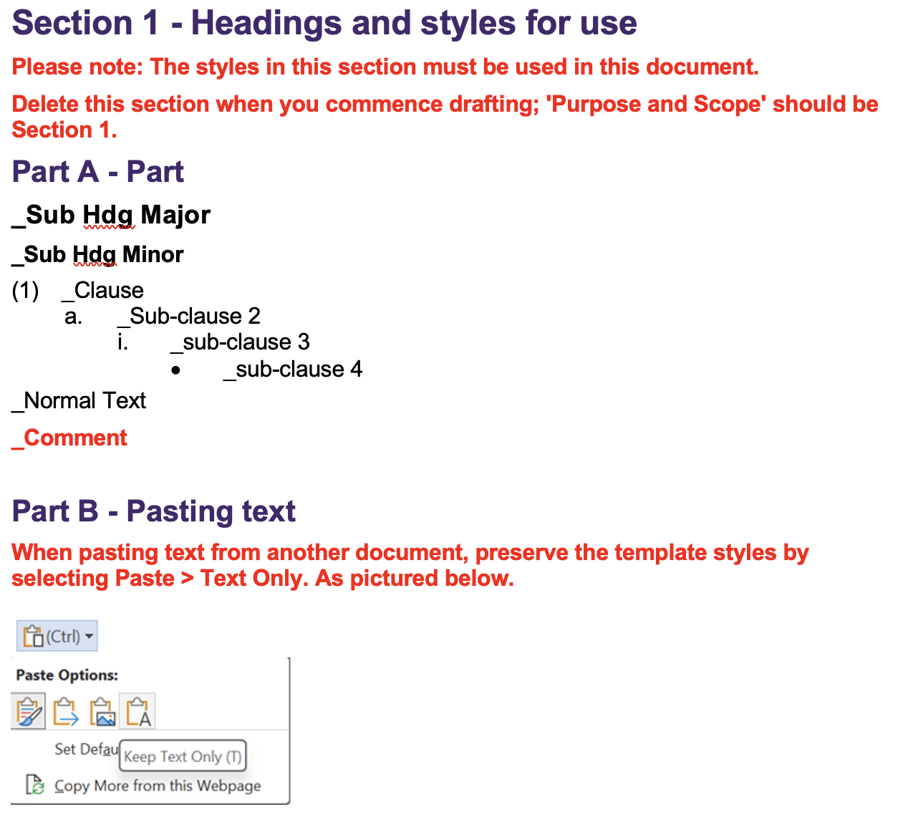
- Purpose and Scope
- State the objective/s of the procedure and which policy it relates to, scope of the subject matter covered; to whom the procedure applies and any important exclusions.
- The information given in this section should be sufficient to demonstrate the importance of the procedure and why it is mandatory.
- Process and Key Controls
- Highlight the important controls and their specific location in the process.
- Key Requirements
- Given the purpose and scope of the procedure, and its parent policy, provide an overview of the process covered by the procedure, and state the major activities and actions required.
- [NOTE: Generally Policy requirements state WHAT needs to be achieved (outputs and outcomes/end goals) and WHY; Procedure requirements state HOW they need to be achieved and WHEN].
- If process is presented as a flowchart or diagram, it may be better included as an appendix.
- The key requirements must clearly align with the objectives of the procedure and the actions required must be verifiable.
- This is the most important section of the Procedure, hence each and every requirement should be able to withstand any close scrutiny or robust challenges.
- The requirements should be stated with precision, be concise, action-oriented and their underlying merits so obvious and convincing to the audience that there is a very high degree of acceptance and compliance.
- Avoid unnecessary or cumbersome impositions on the University.
- Roles, Responsibilities and Accountabilities
- Articulate the responsibilities and accountabilities of the key roles affecting or affected by this procedure (those involved in the development, implementation and management of the procedure).
- The responsibilities and accountabilities should be stated in simple, easy to understand terms and be action oriented (i.e. what needs to be done and who needs to do it).
- Monitoring, Review and Assurance
- Ensure that it is clear what monitoring and review activities will be undertaken and by whom to:
  - Assess compliance with the procedure and to demonstrate/confirm its effectiveness.
  - Identify, assess and promptly address any deficiencies.
  - Ensure ongoing relevance of the procedure.
- Recording and Reporting
- Specify how and where the transactions, activities and results associated with this procedure will be recorded and who would be responsible for the integrity of the records and information.
- Also specify what reports will be produced, by and for whom to demonstrate that the objectives and outcomes warranted by this procedure are being achieved.
- Appendix
- If deemed necessary, use the appendix to:
  - List terms and acronyms used in the procedure and their definitions. If only a few terms and acronyms are used, they may be listed and defined in the body of the procedure, as appropriate.
  - Provide additional information necessary for the reader to better understand the procedure.
  - Ensure any appendices, including mandatory forms, are properly referenced in the procedure.
- Meta Data for Document Management
Correct meta data must be supplied for the document to be published and to enable effective document management.

Metadata
Associated Information | [links and documents to list in the Associated Information tab]
Area of responsibility | [e.g. Directorate, School, Business Unit, etc]
Policy Owner | [Position]
Unit Head | [person reporting to Policy Owner]
Document Author | [person writing the document]
Enquiries contact | [at business area level, if different from area of responsibility]
Document Category | Select applicable from list
Document Realm | Select applicable from list
Target Audience  (select all applicable) | ☐ Staff | ☐ Students | ☐ Community
Next review date | [generally five years from approval date unless required sooner. List the frequency of review cycle, e.g., 3 years, 5 years; or, list particular date if applicable]

Change summary
Amendment summary | [Briefly describe the changes. This commentary will be visible to all PPL users]
Other Notes | [if required]

