[Guideline Title]
A guideline is a document that provides general statements, recommendations or administrative instructions designed to achieve the objectives of a legal instrument, policy or procedure. They are often statements of ‘best practice’ or provide advice on the application of a policy or procedure. Guidelines are not mandatory and are advisory only. Unlike policies and procedures, the format for section headings and sub-headings in this template can be adapted and changed (except for “Purpose and Scope” and “Meta Data for Document Management”).
- Headings and styles for use
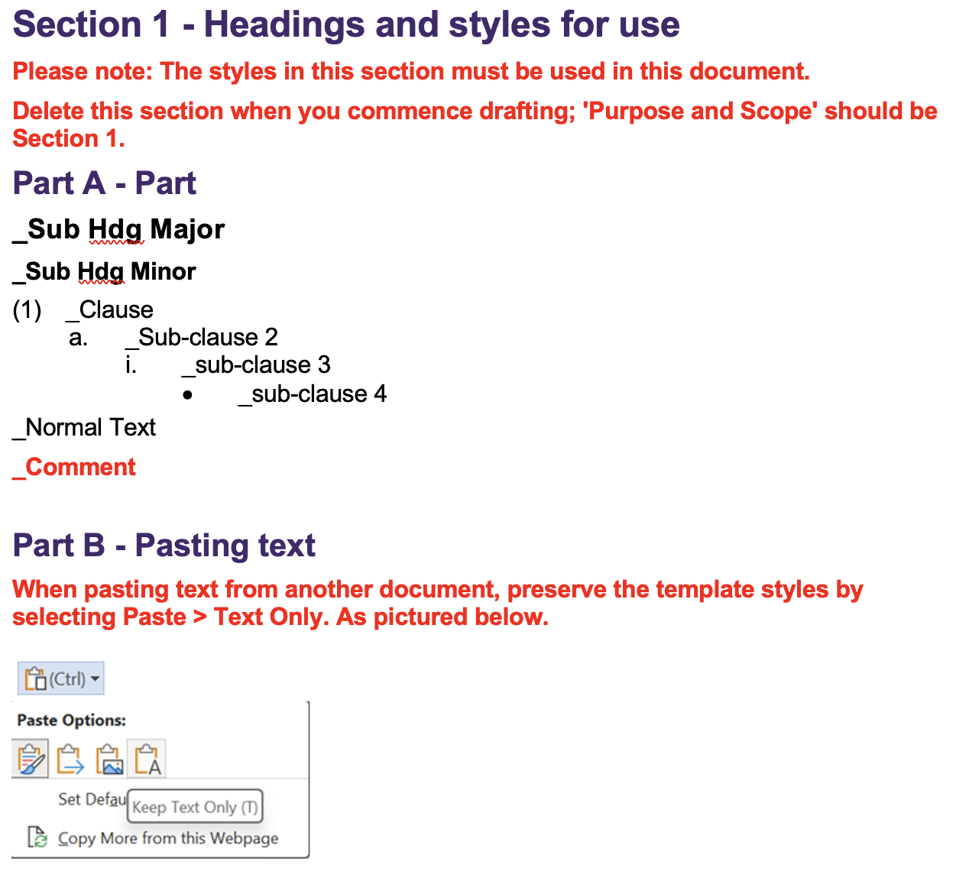
- Purpose and Scope
- State the objective/s of the guideline, outline of the subject matter covered in the guideline and to whom or when the guideline applies. Include reference to relevant legal instrument, policy and/or procedure the guideline gives effect to.
- Appendix
- If deemed necessary, use the appendix to:
  - List terms and acronyms used in the guideline and their definitions. If only a few terms and acronyms are used, they may be listed and defined in the body of the guideline, as appropriate.
  - Provide additional information necessary for the reader to better understand the guideline.
- Ensure any appendices are properly referenced in the guideline.
- Meta Data for Document Management
Correct meta data must be supplied for the document to be published and to enable effective document management.

Metadata
Associated Information | [links and documents to list in the Associated Information tab]
Area of responsibility | [e.g. Directorate, School, Business Unit, etc]
Policy Owner | [Position]
Unit Head | [person reporting to Policy Owner]
Document Author | [person writing the document]
Enquiries contact | [at business area level, if different from area of responsibility]
Document Category | Select applicable from list
Document Realm | Select applicable from list
Target Audience  (select all applicable) | ☐ Staff | ☐ Students | ☐ Community
Next review date | [generally five years from approval date unless required sooner. List the frequency of review cycle, e.g., 3 years, 5 years; or, list particular date if applicable]

Change summary
Amendment summary | [Briefly describe the changes. This commentary will be visible to all PPL users]
Other Notes | [if required]

